澳洲悉尼大学寒假项目

悉尼大学《国际商业思维与法律》，是由全球排名TOP 35th的悉尼大学（The University of Sydney）开发及授课，面向中国各高校学生的菁英课程。
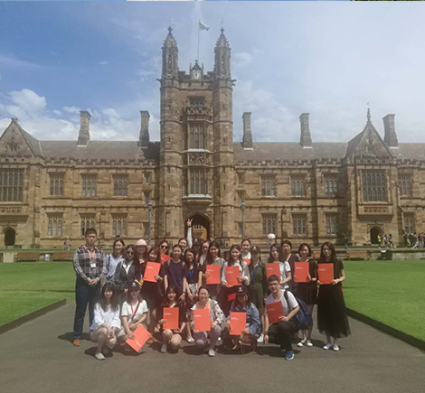2016年1月首批参与学校和学生反馈，该商业课程已获得包括北京大学、人民大学，北京理工大学，中国政法大学等国内的高校认可，参与的国内顶尖高校学生也给予了高满意评价。

自2015年10月起，悉尼大学与“ASI国际教育服务中心”合作，面向中国大陆高校学生开展该菁英课程的招生工作。
教学目的：
1.课程概要：通过西方批判性思维教学方式，帮助中国顶尖高校学生开拓商业思维，了解国际商业运营规则及政府制定商业法律的相关知识。
2. 企业参访：让高校学生提前了解西方公司企业管理及运营
3. 文化之旅：游览澳洲名胜让学生了解澳洲文化
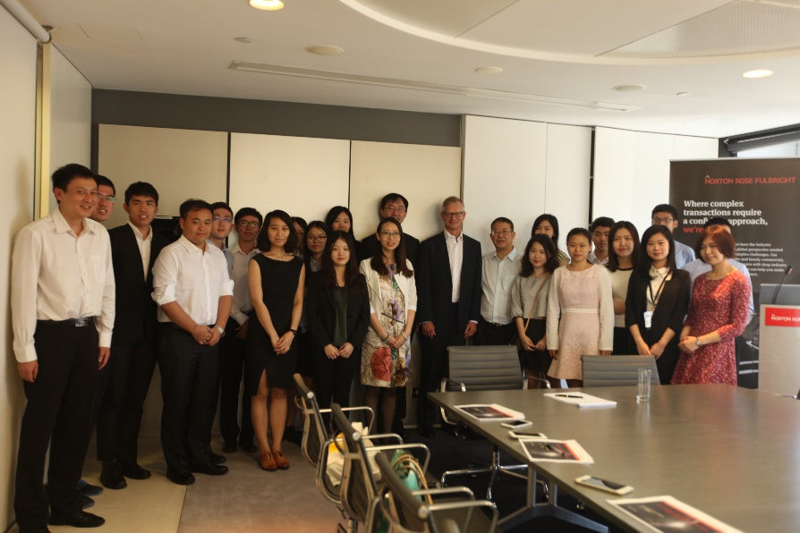

 主要课程：
1. 批判性思维与有说服力的学术写作
Critical thinking and persuasive academic writing
2. 政府立法决策
Sustainability in Government Decision-making: the Legal Requirements
3. 政府责任—可持续决策
Holding Government Accountable for Sustainable Decision-making
4. 环境经济学
Environmental Economics
5. 企业社会责任——环境与可持续性发展
Corporate social responsibility (CSR) – environment and sustainability
6. 复合性与系统性思考
Introduction to complex and systems thinking
7. 澳洲文化和历史
Australian culture and history
 课程时间：
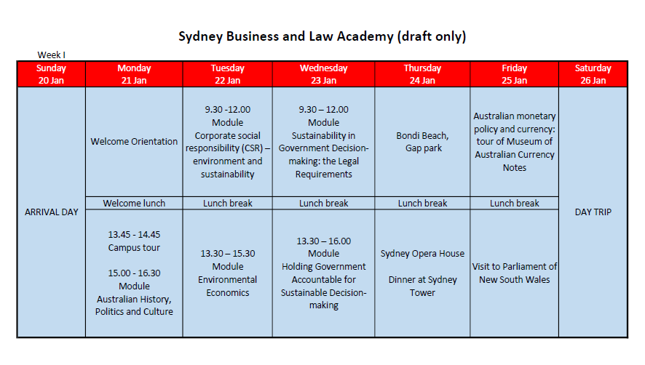

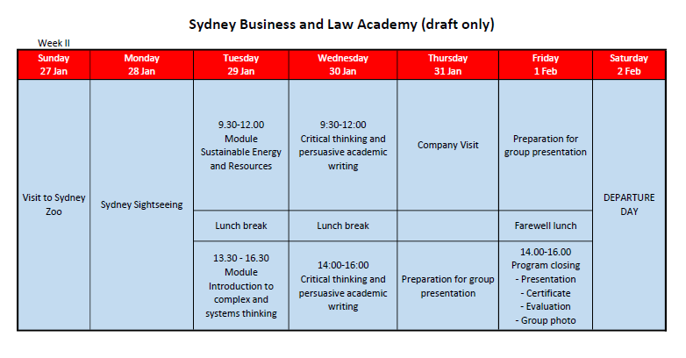

课程费用：7,000澳元/人
费用包含：
1. 课程学费
2. 住宿费（学生宿舍，双人间）
3. 往返机票（限北京、上海、广州往返澳洲；非北上广如有联运需求可另行沟通）
4. 澳洲签证费
5. 接送机/周末短途旅游费用
6. 企业参访
7. 其它费用（悉尼大学开具证书、签证服务费用等）

费用不包含：
1．境外医疗保险费用
2．澳洲司机及导游的小费（约50-80澳币）
3．餐饮费用
4．在澳洲的个人购物消费等
5．个人在中国境内的交通费用
6．其他

2019年度招生计划：
授课时间：2019年1月20日-2月2日
授课地点：澳洲悉尼大学主校区
授课语言：英语
教学成果：悉尼大学young leaders program证书（项目证书+成绩单）

授课教师风采：

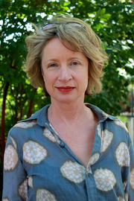
Dr Louise Katz
BA (UNSW), DipEd (Sydney), DCA (UTS)
Lecturer

Louise joined the university in 2009 and currently teaches the two units of study mentioned below. Previously she taught creative writing at the University of Technology, Sydney. Her background is originally in visual arts and she is also a novelist. Louise came later to the teaching of communication skills in industry contexts and from there to teaching academic writing.


DR Gerry Bates
LL.B (Hons), PH.D Birm

Formerly a trainee of the European Community, tutor at the University of Birmingham, UK, and also a lecturer and senior lecturer at Birmingham Polytechnic and the University of Tasmania; and a senior lecturer at the University of Sydney (1996-98).Gerry was an Independent Green Member of Parliament, Tasmania 1986-1995; has been a member of the Board of the Environment Protection Authority of NSW since 1996; a member of the State of the Environment Advisory Council since 2004, and a Director of Kimbriki Environmental Enterprises, a regional waste recovery centre and landfill on Sydney’s Northern Beaches since 2006. He is author of Environmental Law in Australia, Corporate Liability for Pollution and Pollution Law in Australia. He is also Editor of the Environment and Planning Law Journal.

Gerry received a special award from the National Environmental Law Association in 1994 for Outstanding Contribution to Environmental Law; and in 2006 was nominated for a Vice-Chancellor’s Award for Excellence in Teaching at the ANU; and a Carrick Institute Citation for Outstanding Contributions to Student Learning.

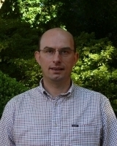
DR Tihomir Ancev

Associate Professor

Tiho Ancev holds degrees from Saints Cyril and Methodius University (Bachelor), University of Iceland (Master) and Oklahoma State University (PhD). His main research areas are environmental, natural resource and agricultural economics. Tiho’s contributions have been in water economics and policy, and economics of air pollution and climate change policies. He has published widely on these topics (Journal of Regulatory Economics, Ecological Economics, Applied Economic Perspectives and Policy, Australian Journal of Agricultural and Resource Economics, Water Resources Management). Tiho has also led and contributed to several national and international projects in these research areas.

课程简介：
Complex thinking
Practical techniques for thinking about and solving complex problems. The 21st Century is throwing us many challenges – from entrenched problems to exciting opportunities. But the world is complex and we need to think strategically, creatively, critically and analytically to achieve outcomes. This session will cover: What is complexity and six ideas for thinking about and solving complex problems.

Sustainability in Government Decision-making: the Legal Requirements
This session will look at how the law defines sustainable development and what the law requires government decision-makers to do with notions of sustainability when making decisions in relation to development and use of natural resources.

Holding Government Accountable for Sustainable Decision-making
This session will look at the ways in which ordinary citizens and NGOs can ensure that sustainability is made an element of government decision-making in relation to development and use of natural resources, ranging from protest action to rights of appeal to courts and tribunals.

Environmental Economics
Environmental economics studies allocation of scarce environmental resources, and optimal management of environmental assets. It examines the choices that individual economic agents and societies make in relation to the use of the environment, and the consequences of that use. This lecture emphasis is exclusively concerned with market failures that impact on the natural environment. Attention is given to why these market failures occur and what role there is for regulation and government policy. Topics covered include efficiency and markets, market failure, externalities (e.g. pollution), various methods of regulating pollution, and measuring the demand for environmental quality.

Critical thinking and persuasive academic writing
Students will be taken through the writing process, which will increase abilities and confidence in cross-cultural communication, composition and digital literacy. Students will be provided with the strategies they need to construct effective arguments and critically analyse their own work.

